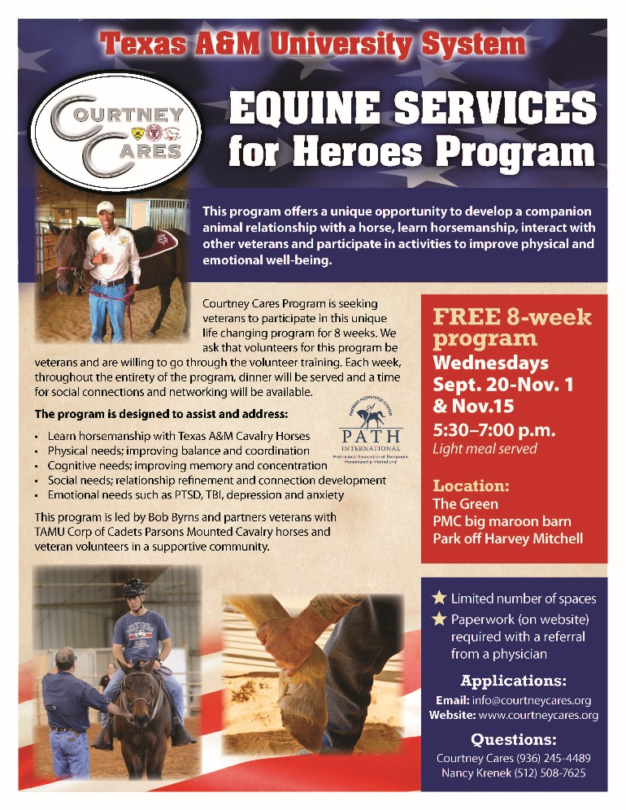
Student Lounge
Our Student Study Lounge is now open to VETV Verified Student Veterans. For more information, contact our office.
Military Appreciation Soccer Game…AGGIE Soccer
Come out and support Aggie Soccer on Friday September 29. This is the Military Appreciation game for soccer this year!
https://drive.google.com/open?id=0B99ernhgWiPMOTQ5SVozN0NBSzg

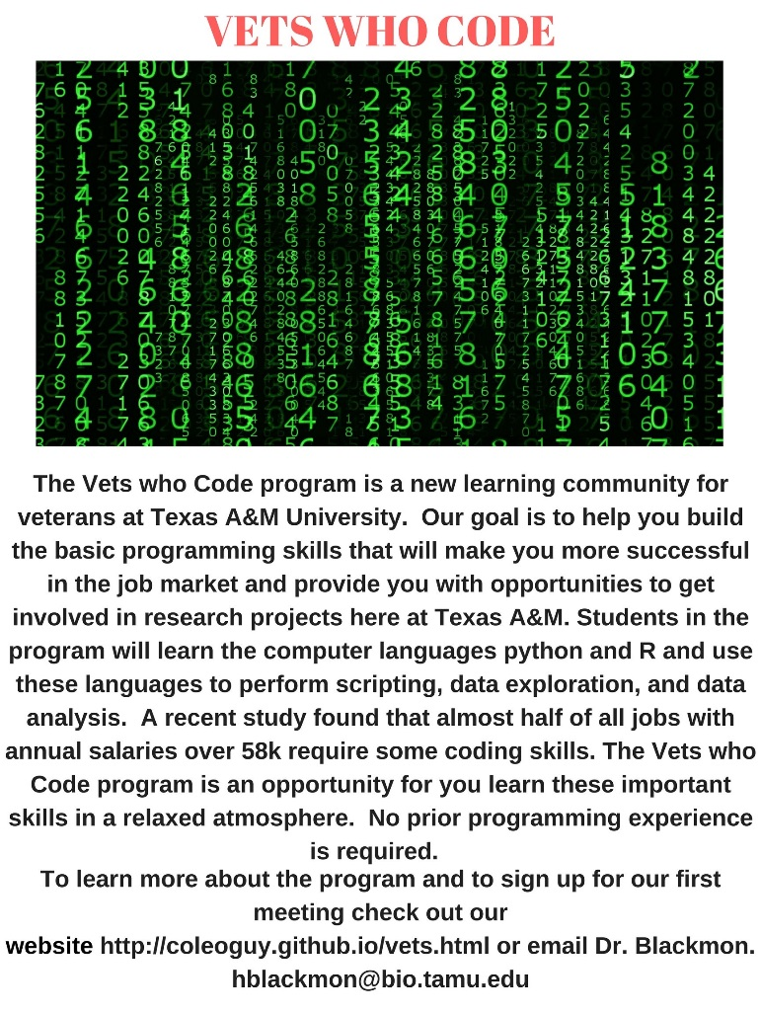
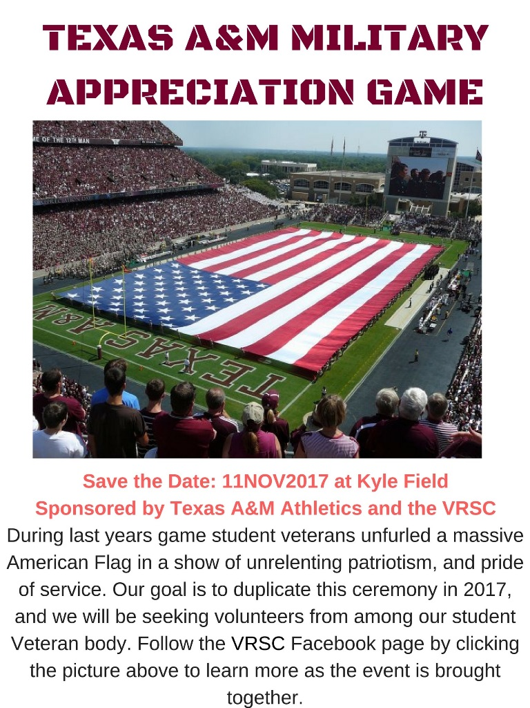
Texas A&M athletics is planning a big Military Appreciation giveaway.

